**Individual Assignment**

Welcome to the first individual assignment in ITEC-3860! The goal from these series of individual assignments is to warm up your programming skills for the final project deliverable for your text-based adventure game. In games of this sort, the player wanders around from one location to another, picking up objects, and solving simple puzzles. The program you will create for this assignment is considerably less elaborate than the final project deliverable and it therefore limited in terms of number of rooms, items, monsters etc. Even so, you can still write a program that captures much of the spirit and flavor of the final game.

This handout contains what you need to know about the first individual deliverable along with a number of hints and strategic suggestions.

**Section 1**

**Overview of the Adventure Game**

The adventure game you will implement for this assignment—like any of the text-based adventure games that were demonstrated by your classmates in class earlier this semester—takes place in a virtual world in which you, as the player, move about from one location to another. The locations, which are traditionally called “rooms” even though they may be outside, are described to you through a written textual description that gives you a sense of the geography. You move about in the game by giving commands, most of which are simply an indication of the direction of motion. For example, you might move about as follows:

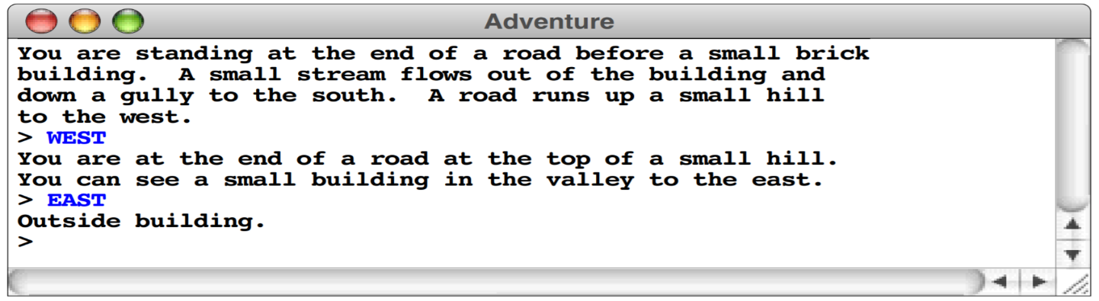

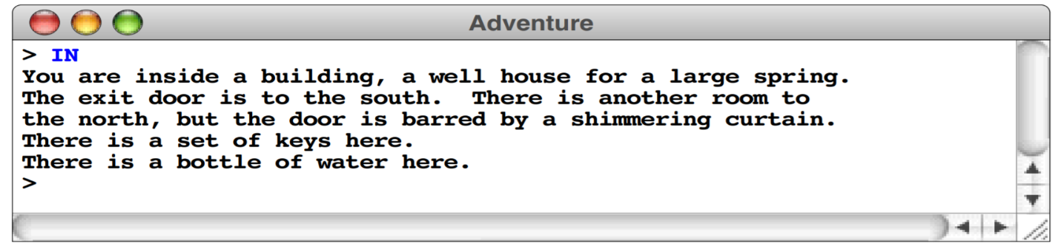

**Overview of the data files**

The adventure program you will create for this assignment and all followed up assignments is entirely data driven. Just like your final project. The program itself doesn’t know the details of the game geography, the objects that are distributed among the various rooms, or even the words used to move from place to place. All such information is supplied in the form of data files, which the program uses to control its own operation. The ultimate goal is if you run the program with different data files, the same program will guide its players through different adventure games.

For this first assignment, there must be an associated data file:

* Rooms.txt, which defines the rooms and the connections between them.
* You can also have two text files, one to define rooms and one to define connections.
* The number of the text file and the structure of the text files are entirely up to you as long as you accomplish the task.

For example, the room data file could have the following information:

* A room number, which must be greater than zero
* Its name, which is a one-line string identifying the room
* Its description, which is a multiline array describing the room
* A flag indicating whether the room has been visited
* A navigation table specifying the exits and where they lead

For example, this data file is not a Java program, but is instead text file that describe the rooms and their connections.

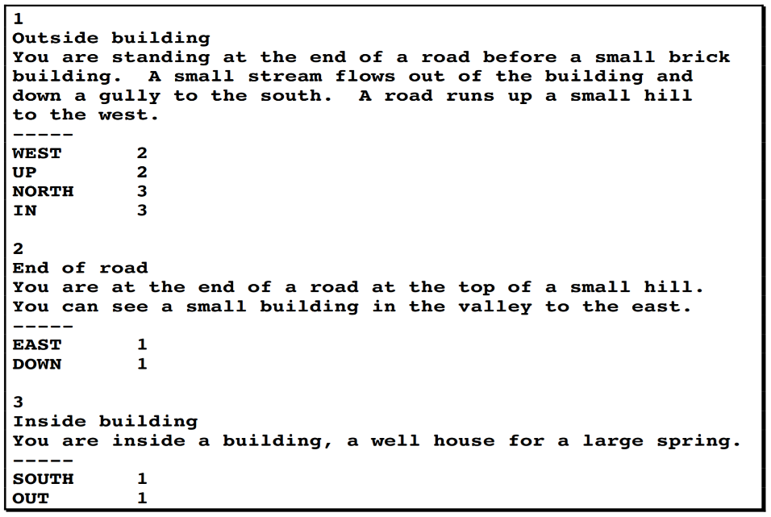

The program you will write for this assignment must:

1. Read the file into an internal data structure, which it then displayed to the user on the console to guide the player through the game.
2. Allow the player to be able to move between rooms by reading and executing navigation commands entered by the user through the console
3. Your program should be able to track visited rooms and display the message visited on the console if the player revisit a room.
4. A total of 6 rooms is required for this assignment with the following navigation command:
   1. North
   2. East
   3. South
   4. West

**Important notes:**

1. Don’t send me screen shots of your code and don’t ask me to trouble shoot your code. This is not a programming class but I found over the years of teaching this class that students need similar programming to review their programming skills and to avoid unnecessary drama toward the end of the semester. To help you I will discuss possible solutions in the class and show you sample code and you will put time and efforts to get your code up and running properly.
2. Use either JAVA Eclipse or IntelliJ
3. Grading code takes lots of time so keep your code clean, organized and understandable by adding comments. The more organized your code is the quicker I can grade and the faster you will get a feedback.
4. Don’t fix the file path in your code
5. If your code doesn’t run you will get ‘0’ for this assignment. If your code runs but have partial behaviuor you will get partial credits. e.g. your code runs and allows me to navigate between rooms but doesn’t keep track of visited rooms, then I will take points off for this missing requirements.
6. The second and the third assignment will add more to the first assignment. Therefore, it is important to finish this assignment on time and as directed. Otherwise, you will fall behind quickly.
7. Below is a sample scenario:

Which direction do you want to go? (N,S,E,W)

E

You are at Room 2

Which direction do you want to go? (N,S,E,W)

W

You cann’t go this way

Which direction do you want to go? (N,S,E,W)

S

You are at Room 4

Which direction do you want to go? (N,S,E,W)

N

This look familiar

You are at Room 2

**What you need to submit:**

1. A map of your game with a clear labels to room names and number.
2. Export your Java project folder, zip it and submit it on d2l.